Day 58

DIY

DIY Questions:

Create two users, Bob and Alice, on the Jenkins Dashboard, and grant each of them matrix-based and project-based authorization, Design a task such that Bob has read all jobs permission and Alice has read all jobs permission as well as build only particular jobs permission.

Tasks:

1. Start Jenkins Dashboard.

2. Go to Manage Jenkins

3. Go to user management

4. Create two users with the names Bob and Alice

5. Go to Global Security and add Matrix-based & project-based authorization to Bob & Alice

6. Bob should have permission to read all jobs only

7. Alice should have permission to read all the jobs and build only a particular job.

Solutions:

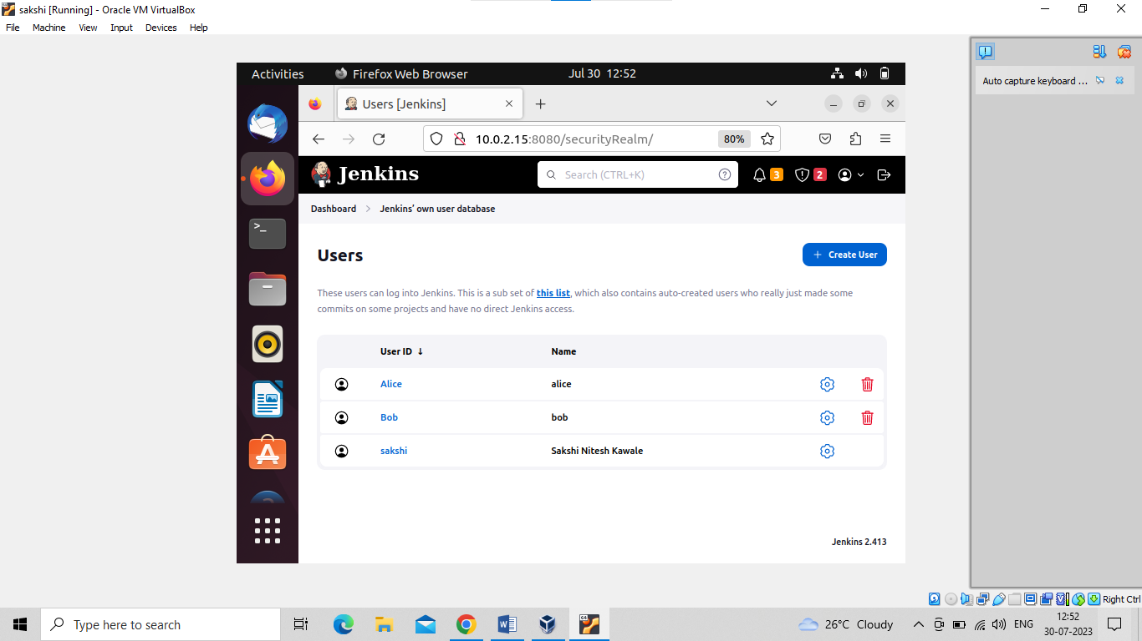

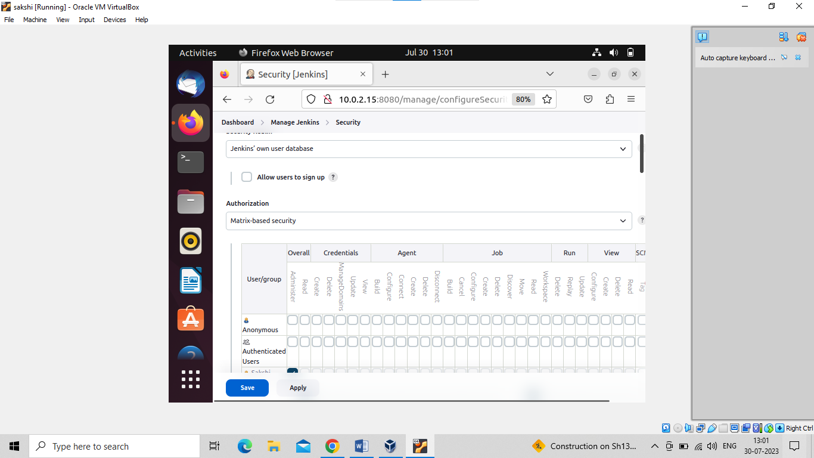

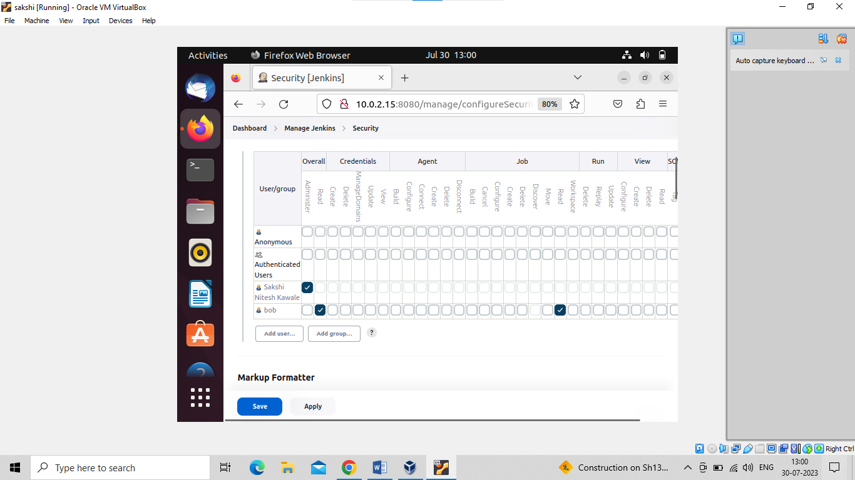

Bob has not manage Jenkins options and build option it has only read only option

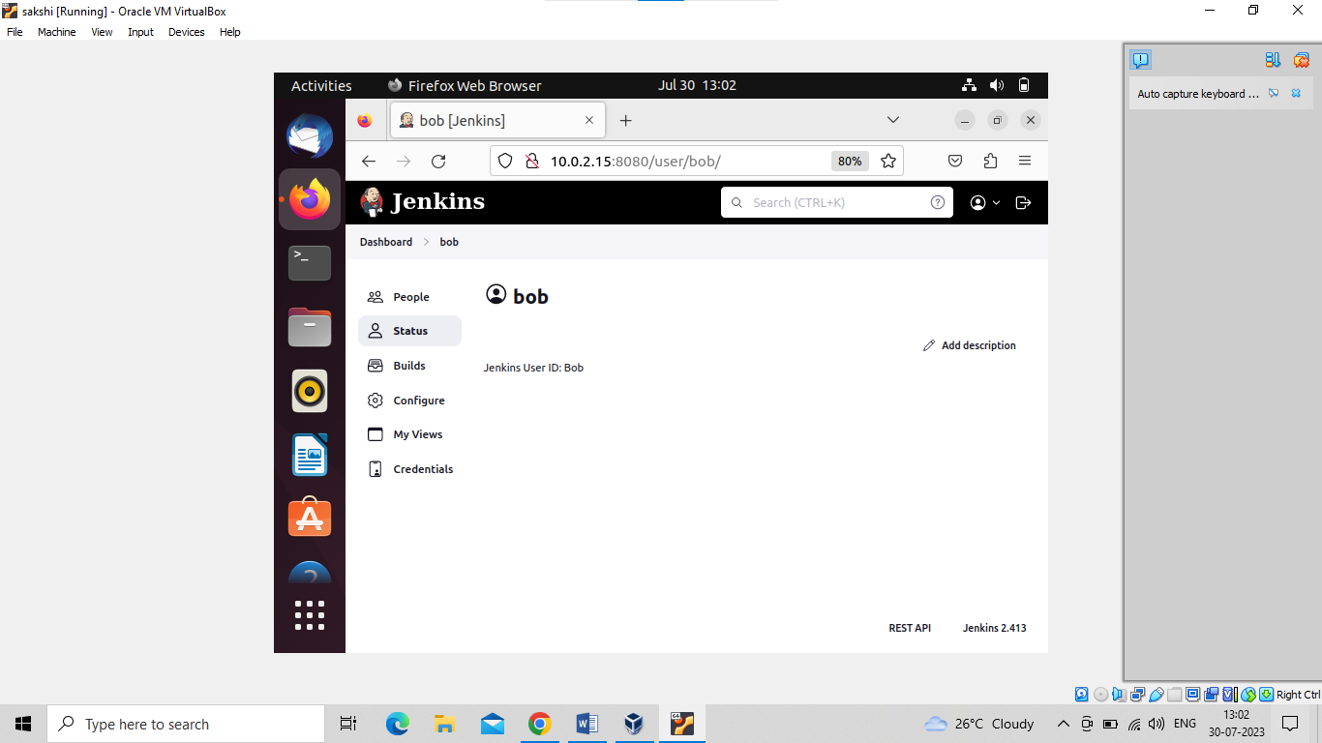

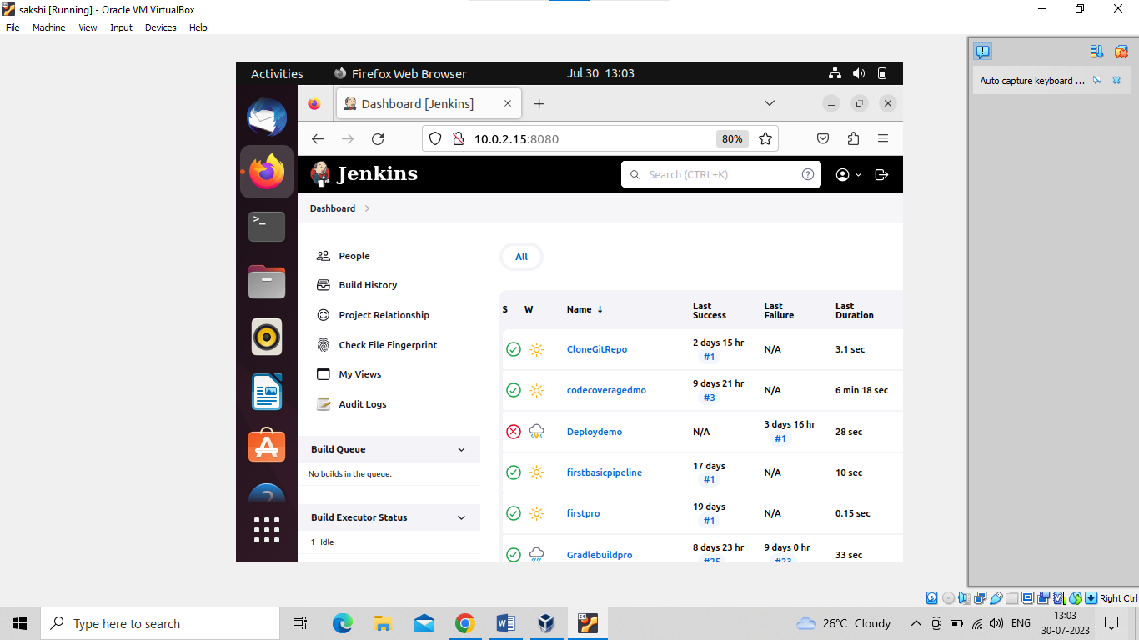

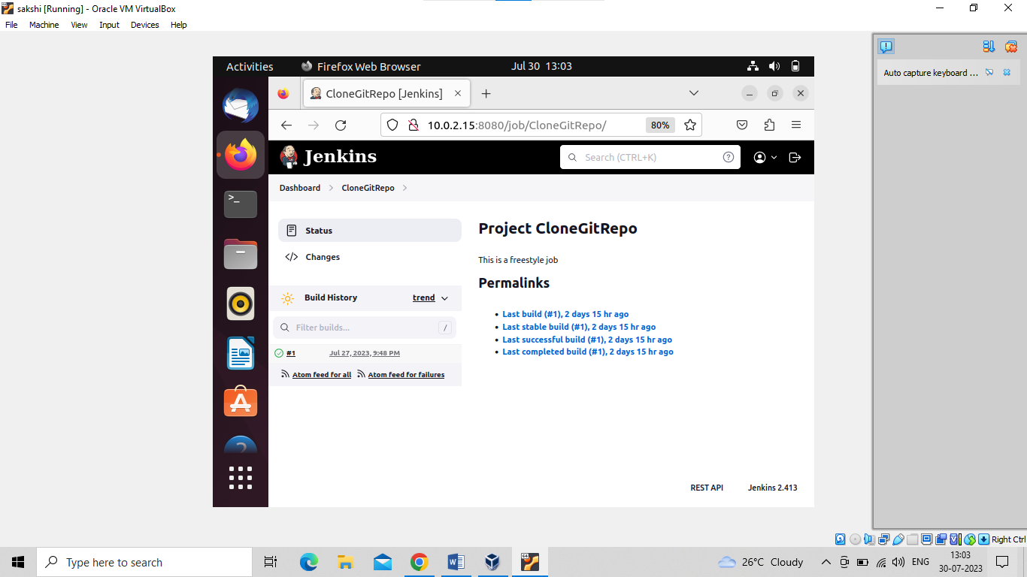

Now give Alice permission

Go to security tab under mange jenkins tab and select project based authorization

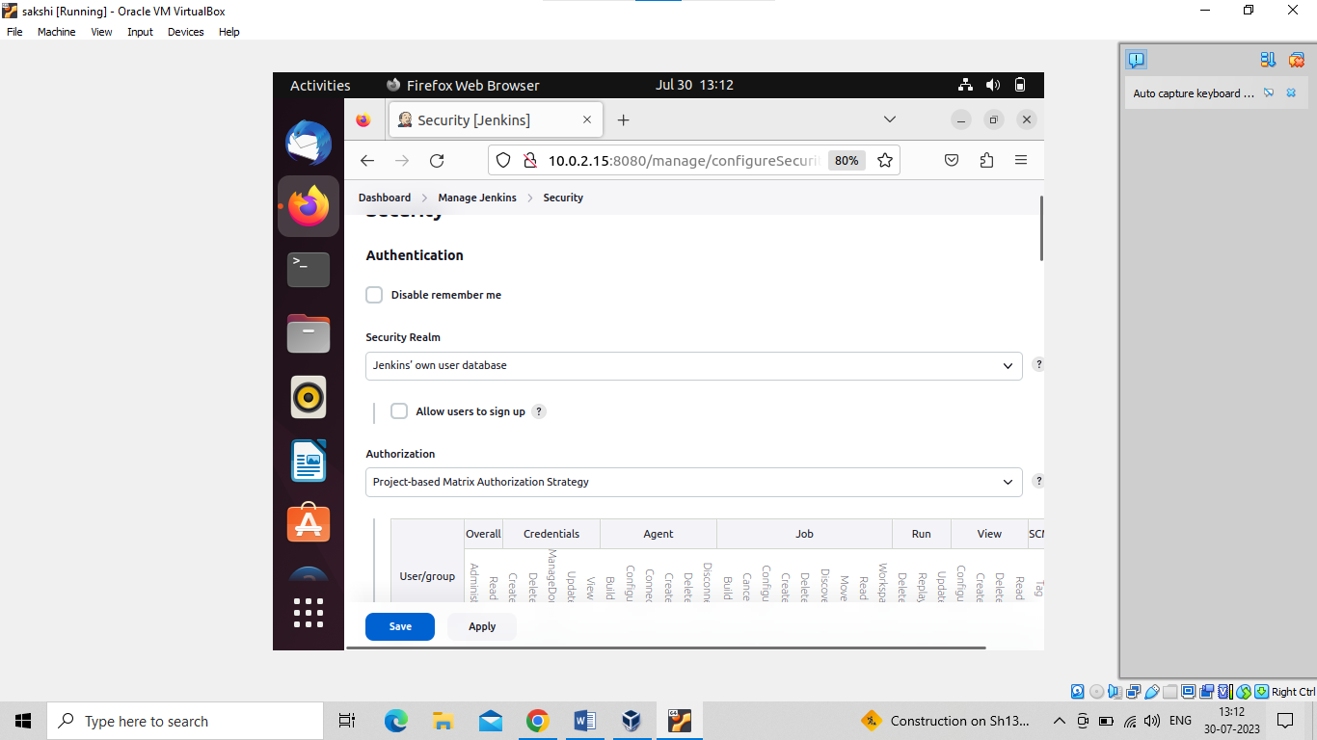

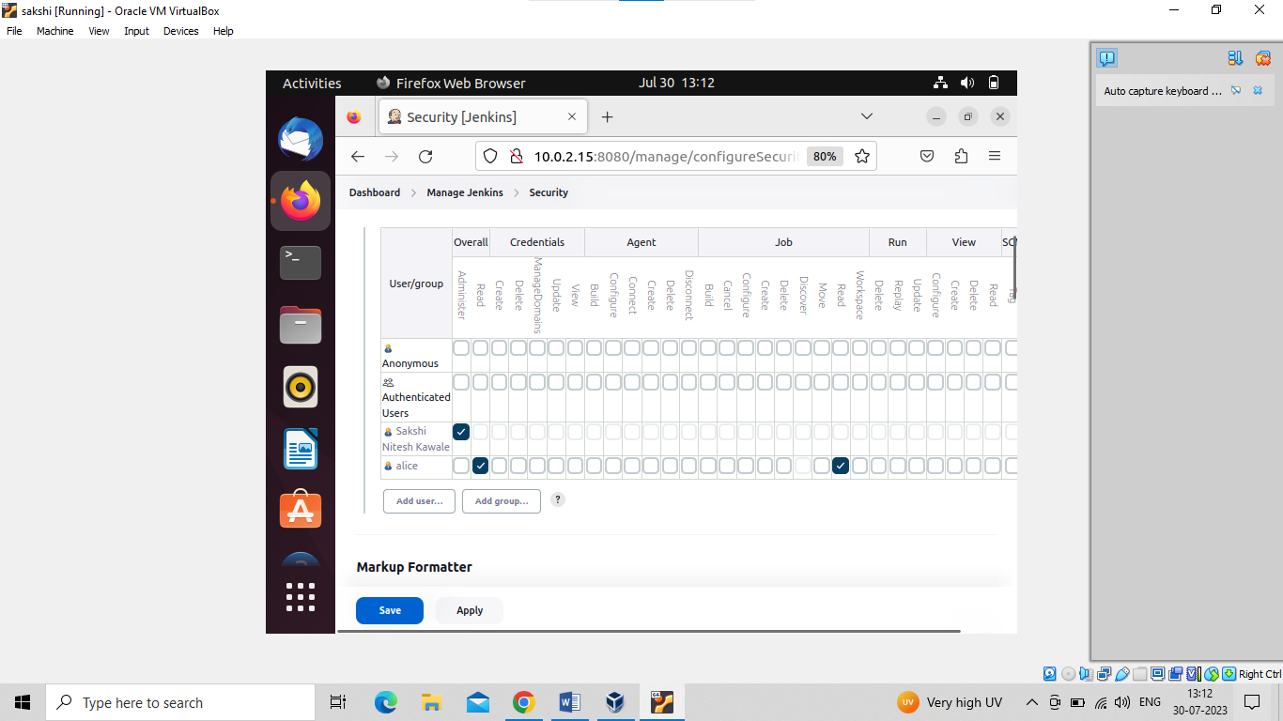

To give build only particular jobs permission go to that particular project under general tab select Enable project based security add the username and give pemission

